Nicole Bishopric
Inquiry Plan
Wiki on Character Education

Model Study:
The study I will be completing will be on the use of wikis in the classroom. I read the study called “Use of wikis in K-12 and higher education: a review of the research” (2009) by Hew and Cheung. I have already experienced wikis in higher education and have found them to be a great tool for organizing information amongst a class. Everyone is able to participate, and learn from others at the same time. The article describes a wiki as a collaborative tool that can be done quickly and still share, gather, and produce information.
Wikis can be created for any subject and expanded based on the amount of content desired. Wikis can be used as a collection of student work, or a collection of group work, so everyone can edit and make sure their work and thoughts are present. Wikis can also be used for class websites, where the teacher can post information, documents such as a syllabus, and allow students to post assignments. Wikis can be a way for teachers to share information that may be useful to other teachers.
Some of the research outcomes reported that students did understand the topic better and they learned more with the use of the wiki. Other studies have found an increase in students’ English writing proficiency from the use of wikis in their class.
This particular study was done on students doing research or writing projects. The wiki in each case acted as the documentation of all the work they put together. This technology was new to many of the students so some of the struggles the students found with the wiki was in editing the page, using the history option to view past changes, and creating new pages.
The authors describe that, with a wiki, open-ended activities should be assigned rather than activities or questions with one answer. This will help to gather a variety of answers as well as discussion and collaboration amongst the groups and class. Open-ended discussions will allow for multiple users to contribute different opinions, which could pose other open-ended questions resulting in further discussion.
The study found that, although grading the individual student wiki work gave incentive for students to contribute, it didn’t mean that the work would be same quality if it was not graded. The study found that some students posted comments that wasn’t necessarily constructive or a new idea. Some students might just, as they said in the article on page 154, “play the game of assessment by adding or editing” just to show that work was done. It is important for students to understand the importance of the wiki and what it is used for and at the same time not to detract from any learning that is happening.
Literature Review:
In the article “Interactive Cooperative Learning” (2010) from the Delta Kappa Gamma Bulletin, Romeo, Brennan, Rothman, and Mitchell described a study they did on the use of wikis in an undergraduate class for many reasons. They chose to use a wiki because it was free, provided a collaborative environment, and was easy to use. Their goal of the program was to create cooperative learning groups and show how it could be used in inclusive classrooms and with using co-teaching. The groups’ assignment was to create lesson plans using the wiki. The group members sat adjacent to one another as they worked cooperatively. The study concluded that the students thought the use of the wiki was educational and they had planned to use it with their own teaching in the future.
In another article, “Wiki as a Collaborative Learning Tool in a Language Arts Methods Class” (2009) from the Journal of Research on Technology in Education by Matthew, Felvegi, and Callaway, preservice teachers are learning how to incorporate wikis by practicing with them in their methods class. The students are learning about the copyright laws, which is important for any research work. With the lessons up on the wiki, other class members are able to post discussions, make comments and suggestions, and post their own lessons that may help others in the class. This is intended to encourage cooperative learning in a class environment which the students/preservice teachers intent to bring to their own classrooms. The researchers randomly chose 5 students from the class to be interviewed about their experience with using the wiki. The students came up with suggestions for future group wki use. They suggested that every student be given a designated role for the wiki. Also, some students posed concern about the accuracy of some of the content their classmates posted on the site because it was not properly references to check on. The results showed positive feedback about the use of the wikis.

Problem:
Schools are beginning to adopt a new program called Character Education. This is to teach values to students and show how they can be integrated into their every day lives. With character education, it is the hope that students will take what they learn and practice it outside the classroom. Often, there is not much documentation of what is learned for students to look back on and be reminded of what each means. Students learn one topic at a time and learn how to apply it, but don’t practice applying it.

Activity:
With this activity, students will be working together on creating a wiki to host all the information they learn about character education. Each topic will be broken up for students in groups of about 4 to work on together. The teacher will create the outline of the wiki, and the students will fill the topic areas in with information, pictures, videos, and podcasts. A rubric will be provided on the site of what the students are expected to include on their site. The wiki that students will be working on together is located at the site: http://characteredmissb.wikispaces.com. Topics may be added as the year progresses. This site will be used to house all the information gathered about character education.
The main topics for the wiki include: cooperation, responsibility, respect, resolving conflicts, and citizenship. Students will be expected to describe their topic so their classmates can understand the terms, write examples of how they have used it, or should use it, and create a video and/or podcast of the topic being put to action.
When the students are done putting together their page about their topic they will present what they learned and created to the rest of the class. The group will show how they use their topic in their everyday lives, and give examples of how they peers can do the same. After all of the presentations are given, everyone will write at least one paragraph about each of the topics discussed, including their own. This will help to determine what was learned from the wiki and if any other information needs to be added. As groups view each other’s projects they will get ideas of what else to include in their next online project, or to add to their current project.

Audience:
This wiki could be used by grade, 2-5 in a school who has adopted this program. The amount of work and content level required for this particular activity is designed for a 5th grade class of 20 students in rural upstate New York State. The entire class speaks English as their first language and have prior knowledge of using computers, the Internet, and recording devices such as a Flip video camera and a microphone.

Objectives:
Learners will demonstrate comprehension of each topic by explaining what each is and how they plan to apply it to their everyday lives.
Learners will demonstrate knowledge of use of the Internet by locating information and materials to be put on the wiki site.
Learners will demonstrate application of the wiki by utilizing the tools the wiki offers, to allow the page to include information in as many ways as possible for making it understandable to the rest of the class.
Learners will demonstrate synthesis of what they have learned by formulating new ways of incorporating what they learned about character education into their daily lives.

Materials:
The majority of the research the students will be doing will be on the computer. The students will need access to the Internet as well as adequate computers. Students will be accessing wikispaces.com to make the edits to their site. They will be using Microsoft Word to write the first drafts of their documents to ensure there are no spelling errors and to make any adjustments before putting the information on the web.
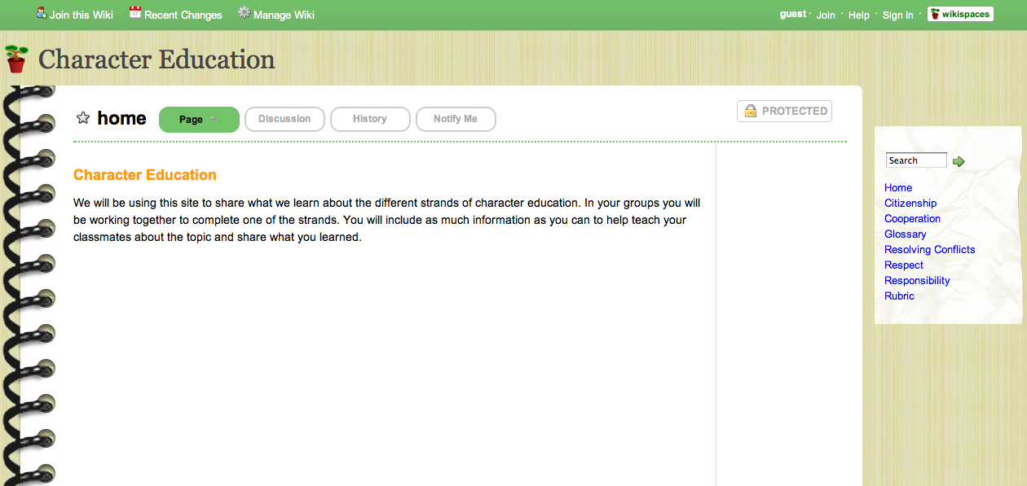
Students will be using the class Flip camera to record their short video. Once the video is recorded they will be using either iMovie or Windows Media Player to make edits to the movie before uploading it to youTube for the embed code. Groups will be presenting their work in front of the class using a projector for display and a portable laptop.

Data Collection:
Students will be required to include relevant examples in their site that help to share how their topic can be applied in their lives. Along with these written examples students must show how they are applying what they learned. Observations will be made before and after the presentations to see if there has been an increase in how the students are treating one another. This will help to determine the effectiveness of the wiki activity. The wiki can be referred to at any time for a refresher and to update any new information.

Evaluation:
A rubric (attached) will be used to determine the level of work the students put together. Every student will be required to contribute in some way. The rubric will be given to each student before they begin their work so they will know exactly what they will be graded on, and what they should include in their site. A copy of the rubric will also be attached to the wiki for students to refer to as they are working.
Students will be required to provide written text as well as either a podcast or a video created by the group. This information will show if the students truly understand the material. Students will be required to present their findings to the class and teach their classmates about the topic they researched. Each group will be the expert of their topic and will be expected to be a role model for how it should be incorporated into the real world.
As an evaluation of the presentation in combination with the materials on the site, everyone in the class will provide a written paragraph about what they learned about each term and how they plan to use it in their own lives. This will be completed ant the end of the presentations. Students will be required to write a paragraph for the topic they researched as well. This will help to ensure that everyone in the group took part in the learning process.

Timeline:
Students will be expected to complete their site within two weeks of their starting date. A little time each day will be given for group work. The first week will be used to gather information and write the text portion of the site. By the second week students should be scripting and practicing for their short video which should be completed by the end of the second week. Students will use a Flip camcorder to record their video, then either iMovie or Windows Media Player to edit their film and get it ready for publishing. The movies should be put into youTube then embedded into the wiki for the class to view. A work schedule would look similar to this:
Day 1: Do research on topic and take notes of information to use.
Day 2: Do research on topic and take notes of information to use.
Day 3: Write first draft of text to put on site.
Day 4: Put written information on site and begin to look for supporting materials.
Day 5: Upload supporting materials such as graphics or links to other sites.
Day 6: Write a script for the video and choose roles.
Day 7: Record the video. This may take a few takes.
Day 8: Edit the video and upload it to youTube then embed it to the wiki.
Day 9: Finalize site and make sure all materials are up.
Day 10: Students will make their presentations to the class.

Dissemination:
The Character Education wiki will be viewed by the rest of the class as well as become available to the rest of the school to view and learn from. Students will be told ahead of time that their work needs to be professional because it will be viewed my others who would like to learn more about the subject. They will need to use accurate information and appropriate content.
Resources:

Hew and Cheung, (2009). Use of wikis in K-12 and higher education: a review of the research. Retrieved from Int. J. Cont. Engineering Education and Life-Long Learning, Vol. 19.

Romeo, Brennan, Rothman, and Mitchell, (2010). Interactive Cooperative Learning. Retrieved from The Delta Kappa Gamma Bulletin.

Matthew, Felvegi, and Callaway, (2009). Wiki as a Collaborative Learning Tool in a Language Arts Methods Class. Retrieved from Journal of Research on Technology in Education.
Wiki Rubric
Your Name: _____________________________
Group Members: _____________________________________________________________________________
Directions: Everyone in the group will need to score their group’s completed wiki. Place a check mark in one box per line in which you feel represents the work on your group’s wiki. Give a score of “0” for the item if it isn’t present, and a “3” if it is present and is very detailed.

Description: | 0 | 1 | 2 | 3
Include topic name and definition
Include examples of how your topic can be used
Embedded at least one video
Video shows the topic being used in an example that is relevant.
Used correct spelling
Used materials such as graphics to support content
Linked text to external Internet sources that may be
Site looks professional and organized.
Used terms that are understandable to your grade level
Everyone in the group did their part

Student Total: _______________
Teacher Total: _______________

Describe your role in your group’s wiki: ____________________________________________________________________________________________________________________________________________________________________________________________________________________________________________________________________________________________________________________________________________________________________________________________________

